**TeamUp – Multiplayer Kinect Game**

**Team Members:** Yaroslav Svirsky, Vova Lando

**Academic Supervison:** Dr. Hanan Gazit

Table of Contents

Project Overview 2

Scenarios 4

Non Goals 5

Sequence Diagram 6

Screen Specifications 8

Additional Issues 9

# Project Overview

Team Up is an original game concept which combines several game genres, multiplayer and control using the Kinect Sensor originally developed for teens and people with special needs.

The game is for two players that have to collaborate in order to progress and succeed in the game.

The game concept is a unique Tetris and Tower Defense combo design, in which the player defend and build solo, but higher levels will require him to play with someone, while game roles separated, one as a Builder, who puts blocks where they supposed to be, and the other, as a Defender, takes care of coming rockets that’s trying to ruin the tower built by Builder. Defender have to use gestures to take care of each rocket, and after the rocket is destroyed, block falls out, the Builder picks and places them into tower, or if the box is "trash box", the one that doesn't fit any available tower spaces, he may let it fall down, and disappear or he may use "trash boxes" as defensive block for defending the tower blocks that are already placed correctly.

The team loses when the rockets have destroyed all the tower blocks.

(*optional)There also possibility to play team vs team, with same tower scheme, and the first team to build, wins.

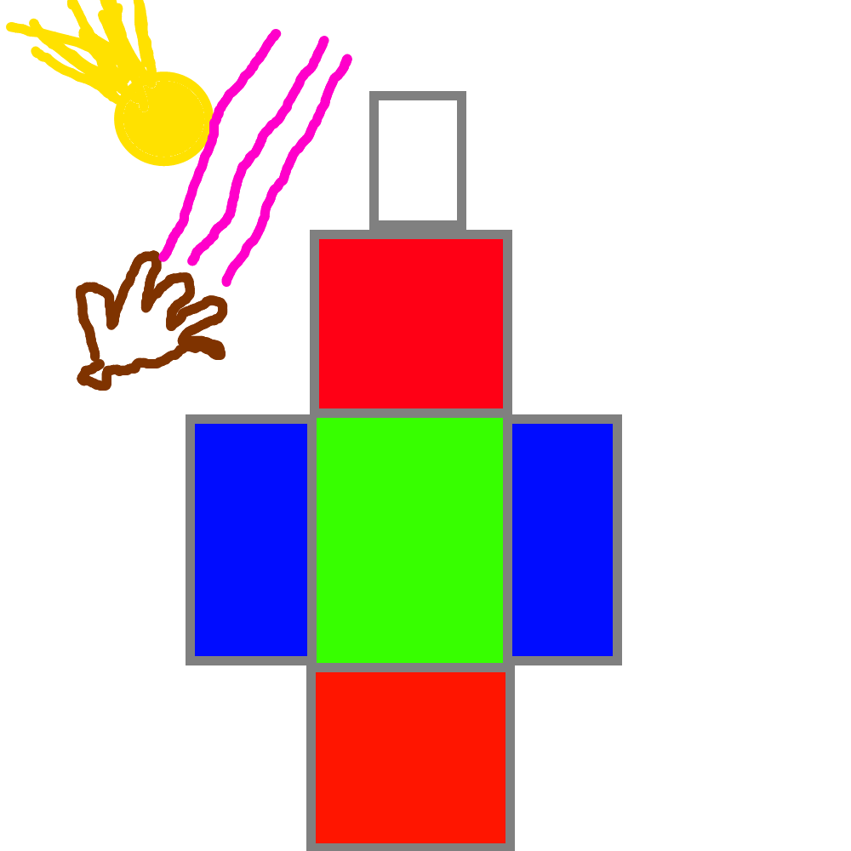picture 1: Game mechanics illustration

# Scenarios

**Scenario Jeffry:**

Jeffry looking for something, that would help him to pass some time. He downloads a new game called "Team Up", runs the game, watches the tutorial, plays solo game, and finds it very addictive and fun. Day after he comes early from work, and decides to try the Multiplayer mode, where tough guys compete. So he runs the game and spends more of his spare time on it, but achieves some pretty good score, and finds new friends. The Game becomes part of his life, he is constantly happy and helps other players to play the game.

**Scenario Mikola:**

Mikola is a disabled guy from little village in the south of Belarus, when he was young, "horse cart" went through his back, his father is a CEO at the big "kolkhoz", so he brought him PC, just to make sure he is not going to suffer of boredom.

Mikola started to play solo game in a handicap mode, and it makes him feel better. One of the main goals of the game is to help disabled people all over the globe.

# Non Goals

This version will not support:

* Player profile
* Solo Game Mode
* Tutorial Mode
* Profile
* Xbox support
* Some GUI and Tutorials may be missing

# Sequence Diagram

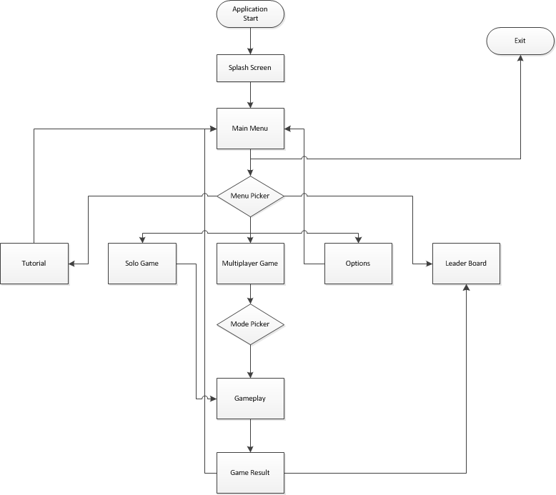**Levels for player**

As player advance through the game, he scores points that update his overall score, this score shows us the players ability to handle difficulty level.

Levels are generated dynamically based on both players overall score. This mechanics supposed to make the game challenging and fun for players of different skill.

We named this mechanism 2DMLS (Dynamic Difficulty Matchmaking Level System).

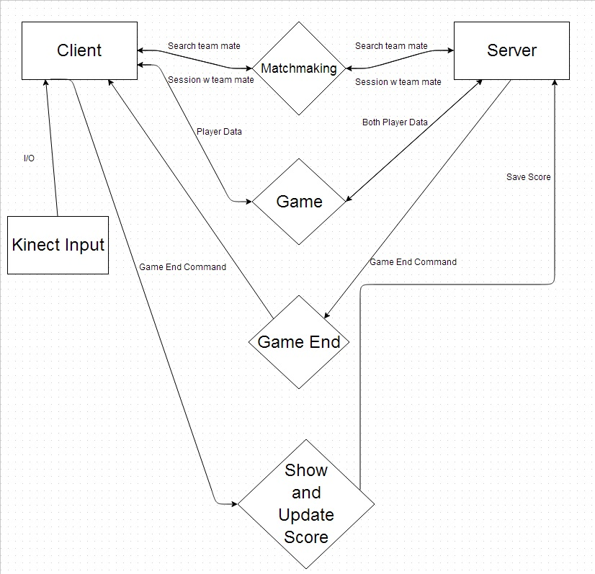**Client - Server - Kinect Diagram**

# Screen Specifications

**Splash Screen:** Studio Name animation Fade from inside of the screen to user.

**Loading Screen:** Game Loading Progress, with status indicator and game Poster at the background.

**Menu Screen:** Menu Items in a half cycle at the bottom half of the screen, On the top right corner of the screen there will be animation of someone describing to "user" how to play and what to choose. In the middle, small game animation, something with Game name, and a little of gameplay

**Menu Items:** Solo, Multiplayer, Tutorial , Options, Leader-Board

**Options:** Sound FX Level + On/Off Switch, Music Levels + On/Off Switch, Set Handicap mode, Reset Progress

**Solo screen:** Solo Game screen

**Multiplayer screen:** One Team Cooperate, Player vs Player, Team vs Team

**Leader Board screen:** Show Leader board

**Game Screen:** The playing screen by itself.

**Conclusion Screen:** Victory/Defeat animation

**Result Screen:** Number of points with options to upload score to leaderboard

# Additional Issues

*Decide where the server would be placed, the options are:*

* Player hosts server for the game, and joins the games pull in the big server, which just makes the matchmaking and sends level for the game
* Everything goes on the server side

*Decide about server side technology, upon previous issue we have to decide what technology we should use for server side*

*Find someone who can make all the assets of UI, Animations and so on.*